**Context and Motivation**

Water availability is quite an essential factor for various purposes such as agriculture, domestic usage, industrial usage, etc. In the last few years, due to climate change, the regular weather patterns have been disrupted which in turn has affected water availability. The issue of water availability is extremely relevant in the Indian context, which is home to 18 percent of the world’s population, but possess only 4 percent of its water resources (<https://www.worldbank.org/en/country/india/brief/world-water-day-2022-how-india-is-addressing-its-water-needs>). Studies show that 40% of the population will have absolutely no access to drinking water by 2030( <https://www.orfonline.org/expert-speak/india-water-crisis-permanent-problem-which-needs-permanent-solutions-52896/> ).

One of the major reasons for such a dire situation is the unplanned usage of water resources. One recent report mentions that nationally over 70% of the surface irrigation water is being simply wasted (<https://timesofindia.indiatimes.com/city/chandigarh/70-of-irrigation-water-is-wasted-mohapatra/articleshow/86051809.cms> ). Besides the rate of groundwater extraction is also quite alarming. Water management, therefore, is the only way to treat India’s water crisis that will soon snowball into a national calamity.

So, in order to address these issues, sustainable usage of water resources is necessary. This can arise only from informed consumption. This is quite a challenge as there is not much awareness in the ground level about water usage planning. Only an informed consumer can be an empowered consumer. The planned and informed use of water can assist several sustainable development goals.

* Clean Water and Sanitation: To improve the standard of living and prevent many water-borne ailments which can lead to Good Health and Well-being
* Sustainable Cities and Communities: Can help authorities prevent periods of water stress and allocation between various sectors which can help in Responsible Consumption and Production
* Industry, Innovation, and Infrastructure

If we can equip the communities at the ground level with the knowledge of water availability, this can empower them to make informed decisions for water usage planning. For example, depending upon the amount of water available, a farmer can decide what kind of seed to go with; the local authorities can decide on the actions required to be taken in case of water stress. This has a further advantage of addressing overuse of groundwater, which is a challenge in India. For this purpose, we want to make it possible for common people to monitoring local reservoirs and dams more accessible and easily understandable.

**Data and Methodology**

For this purpose, we use Sentinel 2 satellites L2A data (<https://registry.opendata.aws/sentinel-2-l2a-cogs/> ). Sentinel-2 carries the Multispectral Imager (MSI). This sensor delivers 13 spectral bands ranging from 10 to 60-meter pixel size in visible spectrum, near infrared and short-wave infrared. Its blue (B2), green (B3), red (B4), and near-infrared (B8) channels have a 10-meter resolution. Next, its red edge (B5), near-infrared NIR (B6, B7, and B8A), and short-wave infrared SWIR (B11 and B12) have a ground sampling distance of 20 meters. Finally, its coastal aerosol (B1) and cirrus band (B10) have a 60-meter pixel size. It also provides AI-processed pixelwise classification data into water, soil, vegetation, snow, etc.

To measure the water content, one of the measures used is Normalized Difference Water Index (NDMI). It detects moisture levels in vegetation. It is calculated as a ratio between the NIR (Band 8A) and SWIR (Band 11) values of the satellite bands. The expression for calculating NDMI is:

NDMI = (B8A – B11)/(B8A + B11)

The maximum value possible for NDMI is 1 (corresponding to a water-logged area) and the minimum value possible is -1 (corresponding to a dry area).

However, the data from these different bands are not as clean as we would like it to be. Many a times, clouds affect the measurement. For example, if a cloud comes over a particular water body it can lead to the NDMI value being affected due to the water content in it. So, we must omit all the data where a lot of clouds are present.

This is specifically challenging during the months of June-December when India experiences two seasons of monsoons.

1. South-West Monsoon: June to September
2. North-East Monsoon: October to December

The presence of clouds is extremely high specifically during the South-West monsoon. As a result, quite often none of the images taken during this period end up as useful. North-East monsoon exhibits this behaviour to a lesser extent. Thus, we may still get some data points during this period. In the months January-May, the obstruction due to clouds are far less. Hence, we need to exclude all those measurements when clouds obstruct the ground surface.

*Figure* 1Example of a cloud obstructed view

For this purpose, we used the neural networks-processed scene classification data obtained from the repository. This data tells us which of the pixels are probably clouds, vegetations, snow, etc. ( <https://sentinels.copernicus.eu/web/sentinel/technical-guides/sentinel-2-msi/level-2a/algorithm> ). Though not 100% accurate, this information gives us a good estimate. With the help of this information, we excluded all the images with more than 20% of the pixels are defined as one form of cloud or another.

Since we are interested to monitor how a given water body changes its water levels during summer, this is all the information we need. Provided the coordinates of a waterbody, we can get the corresponding satellite data from the repository. It is to be noted that to get a better analysis, we need good data. Hence when providing the spatial coordinates of the lake, one must consider the maximum spatial extent to which the water body can spread out. One must also note that the assessment cannot be performed for small waterbodies like ponds or wells due to the limits in the resolution which is 20m per pixel. It is advised to consider waterbodies with dimension in km ranges.

Once the NDMI values are obtained, we sum them for the selected region. It represents the water content available for the whole area in and around the water body. We then visualized and analysed how the NDMI sum for a region changes with time. It was observed that observed that the number of pixels with high NDMI values tend to decrease linearly from October to June. With the help of this, we can compare how much water is present initially in the reservoir and how fast it decreases every year. For example, a high value NDMI sum indicates abundance of water, which indicates that there might not be water stress during the summer. However, a faster decay of the NDMI sum indicates probable water stress. Based on this linear relation we can predict the water levels in the months leading up to the monsoon with a decent accuracy.

Next, let us consider the reservoirs that we used for our case study.

**Case Study 1: Malavi Dam, Karnataka**

Malavi reservoir was built in 1972 to augment rainwater and provide irrigation cover to few chronically drought-prone villages in the vicinity.

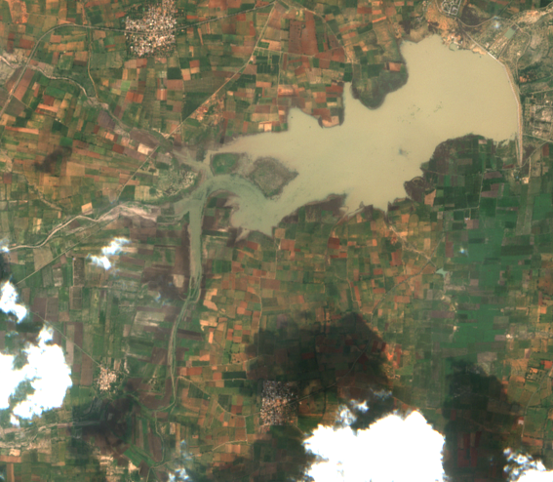

*Figure 2*Malavi dam in 29 Oct 2017. One of the peak capacities.

*Figure 3* Malavi Dam NDMI on 29 Oct 2017. The brighter the colour the more the moisture, the darker the colour less so.

*Figure 4*Dried up Malavi dam on 27 May 2017.

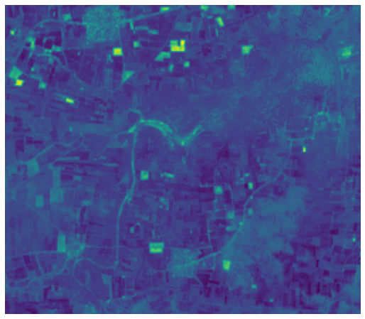

*Figure 5*NDMI of dried up Malavi Dam on 27 May 2017. The brighter the colour the more the moisture, the darker the colour less so.

On comparison, we can see that the figure (27 May 2017) below has just a few patches where NDMI value is high whereas the above image (29 Oct 2017) there is an abundance of moisture around.

*Figure 6*Annual trend in the variation of sum of NDMI values for the selected region. We can see that this behaviour is more or less linear.

In order to analyse the trends in moisture content, we used the sum of NDMI. That way we felt that it can account for the moisture content around the waterbody as well. The NDMI sum starts with a peak value for the year and reduces as the summer proceeds. One can also see that by end of February/beginning of March, the trend for the rest of the summer is set. For example, we can see that 2019 was one of the driest summers. Comparing 2022 and 2018, we can see that though the initial moisture content in January (0-30) was not the same, they ended up having similar NDMI by the end of May (~120). We can say that this is due to higher intensity of 2022 summer (though good rain was received in the latter half of 2021) as opposed to 2018.

*Figure 7*Linear Regression of NDMI sum from Oct 1 to June 1 in the given years. We can see that linear regression does an excellent job of predicting the trends.

So, once we have the data from October to January/February, we can predict what will be the NDMI sum for the region. Based on that value, we can find the point from historical data which will show the closest behaviour. This would help the people visualize how the summer will be.

**Case Study: Gandipalem, Andhra Pradesh**

Gandipalem Project was constructed during period of 1975 to 1984 about across Pillaperu river. The dam was built as the irrigation source for 17 villages located in drought areas in Udaygiri and Varikuntapadu Mandals. The irrigated area registered under the project is 10.26 km².

*Figure 8*Gandipalem Reservoir on 2022 Feb 2

*Figure 9*Gandipalem Reservoir on 2017 Feb 3. The brighter the colour the more the moisture, the darker the colour less so.

*Figure 11* Trend in sum of NDMI over the years for the period from Jan to June

In order to analyse the trends in moisture content, we again used the sum of NDMI. One can also see that by end of February/beginning of March, the trend for the rest of the summer is set. For example, we can see that 2019 was one of the driest summers as in the case of Malavi dam. However, 2019 also was quite a dry year in this case. Comparing 2022 and 2020, we can see that though the initial moisture content in January (0-30) was similar, they ended up having different NDMI in March and April (~120). The behaviour of NDMI in this reservoir is not as straightforward as Malavi.

*Figure 12*Linear Regression of NDMI sum from Oct 1 to June 1 in the given years. We can see that linear regression does an excellent job of predicting the trends.

Nonetheless, the change in NDMI is more or less linear. What one should notice is that there is scant data during November and December. This place is closer to East Coast where North-West Monsoon is stronger in these months, hence this behaviour. So, once again, once we have the data from October to February, we can predict what will be the NDMI sum for the region. Based on that value, we can find the point from historical data which will show the closest behaviour. This would help the people visualize how the summer will be.

From these two case studies, we can see that it’s better to have data up to at least February or March to predict the trend for the summer.

**What We Offer**

Our aim is to provide easy access to the climate trends to the commonest people. Hence, we prefer to provide the visual information to the end-user. Once the region is chosen, our analysis provides:

* Historical trends during summer
* The occasions of maximum and minimum moisture content
* Probable behaviour during peak summer once we have data from October to January/February
* Most probable state of the reservoir by visual information by referring to the historical data